**Classroom Activity: Building Simple React Application – Advise Generator Application**

**Program Structure**

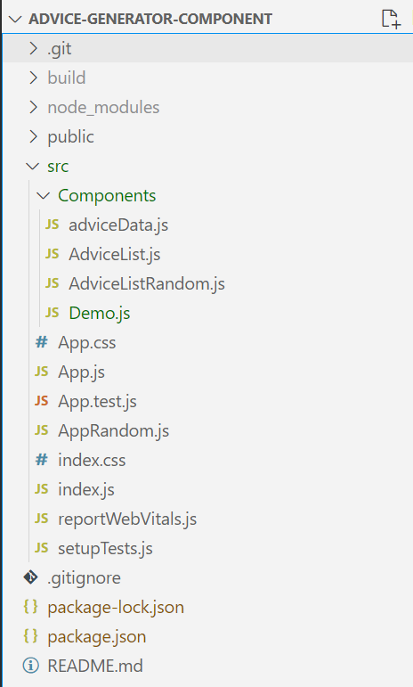

Figure: Advice Generator Program Structure’s Screenshot

**Code:**

File Name: src/Components/AdviceList.js:

|  |
| --- |
| import React, { useState } from 'react';  import adviceData from './adviceData';  const AdviceList = ({ onSelectAdvice }) => {    const [category, setCategory] = useState('');    const getRandomAdvice = (category) => {      const advices = adviceData[category];      const randomIndex = Math.floor(Math.random() * advices.length);      return advices[randomIndex];    };    const handleGenerateAdvice = () => {      if (category) {        const advice = getRandomAdvice(category);        onSelectAdvice(advice);      }    };    return (      <div>        <select value={category} onChange={(e) => setCategory(e.target.value)}>          <option value="">Select a category</option>          <option value="financial">Financial</option>          <option value="health">Health</option>          <option value="education">Education</option>        </select>        <button onClick={handleGenerateAdvice} disabled={!category}>          Get Advice        </button>      </div>    );  };  export default AdviceList; |

**src/Components/adviceData.js**

|  |
| --- |
| const adviceData = {    financial: [      "Save a portion of your income regularly.",      "Create a budget and stick to it.",      "Invest in your future.",      "Avoid unnecessary debt.",      "Build an emergency fund.",      "Track your spending.",      "Plan for retirement early.",      "Diversify your investments."    ],    health: [      "Eat a balanced diet.",      "Exercise regularly.",      "Get enough sleep.",      "Stay hydrated.",      "Avoid smoking and excessive alcohol.",      "Manage stress effectively.",      "Maintain a healthy weight.",      "Regularly check-up with your doctor."    ],    education: [      "Never stop learning.",      "Read regularly.",      "Seek out mentors.",      "Practice critical thinking.",      "Stay curious and ask questions.",      "Manage your time effectively.",      "Set learning goals.",      "Take breaks to avoid burnout."    ]  };  export default adviceData; |

**src/App.js:**

|  |
| --- |
| import React, { useState } from 'react';  import './App.css';  import AdviceList from './Components/AdviceList';  function App() {    const [advice, setAdvice] = useState('');    return (      <div className="App">        <header className="App-header">          <h1>Advice Generator</h1>          <AdviceList onSelectAdvice={setAdvice} />          {advice && <p>{advice}</p>}        </header>      </div>    );  }  export default App; |

**src/index.js:**

|  |
| --- |
| import React from 'react';  import ReactDOM from 'react-dom/client';  import './index.css';  import App from './App';  import reportWebVitals from './reportWebVitals';  const root = ReactDOM.createRoot(document.getElementById('root'));  root.render(    <React.StrictMode>      <App />    </React.StrictMode>  );  // If you want to start measuring performance in your app, pass a function  // to log results (for example: reportWebVitals(console.log))  // or send to an analytics endpoint. Learn more: https://bit.ly/CRA-vitals  reportWebVitals(); |

**public/index.html:**

|  |
| --- |
| <!DOCTYPE html>  <html lang="en">    <head>      <meta charset="utf-8" />      <link rel="icon" href="%PUBLIC_URL%/favicon.ico" />      <meta name="viewport" content="width=device-width, initial-scale=1" />      <meta name="theme-color" content="#000000" />      <meta        name="description"        content="Web site created using create-react-app"      />      <link rel="apple-touch-icon" href="%PUBLIC_URL%/logo192.png" />        <link rel="manifest" href="%PUBLIC_URL%/manifest.json" />        <title>Advice Generator</title>    </head>    <body>      <noscript>You need to enable JavaScript to run this app.</noscript>      <div id="root"></div>    </body>  </html> |

**OUTPUT:**

|  |
| --- |
|  |

Figure: Output Screenshot 1

|  |
| --- |
|  |

Figure: Output Screenshot 2

**Execution Steps:**

* Write the above code as per the program structure
* Go to VS Code terminal
* Execute following command to run the program: npm start
* This will open your default browser and navigate to http://localhost:3000, where you will see your new React application running.